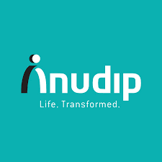 AnudipFoundation
Name: Soumyadip Das
Student Id: AF05102864
Topic: Information Technology (IT Fundamental)



How To Work A Computer?
A computer works on an input-process-output (IPO) cycle, taking data via input devices (keyboard/mouse), processing it in the CPU, storing it in memory, and displaying results on an output device (monitor). Key components include the CPU (ALU + Control Unit), Memory, and Input/Output units

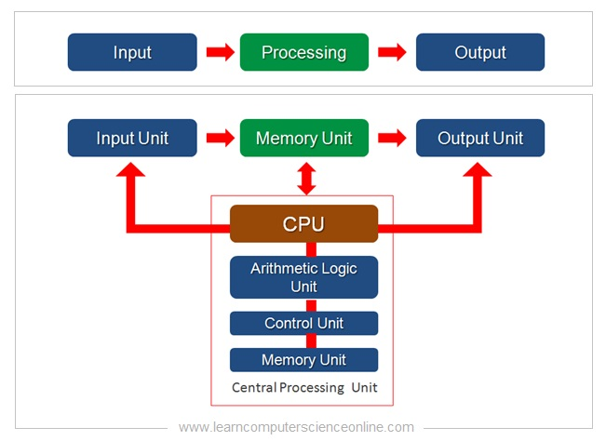

What Is Data?
Data is a collection of raw, unorganized facts, figures, symbols, and observations—such as numbers, text, images, or audio—that have not yet been processed to reveal meaning.
What Is Information?
Information is processed, structured, and organized data that is meaningful, relevant, and useful to the receiver.
What is Information Technology?
Information Technology (IT) is the use of computers, storage, networking, and physical devices to create, process, store, secure, and exchange all forms of electronic data.
Key Aspects of Information Technology:
- Definition & Function: IT involves managing and processing data using technology, encompassing both computing and telecommunications.
- Components:
  - Hardware: Servers, computers, and peripheral devices.
  - Software: Applications, operating systems, and databases.
  - Networking: Infrastructure for communication (routers, switches).
- Core Activities: Data storage, retrieval, transmission, security, and analysis.
- Business Impact: IT acts as a foundation for modern business, driving efficiency, supporting decision-making, and enabling digital transformation.
Common IT Roles and Subsets:
- Cybersecurity: Protecting data and systems.
- System Administration: Managing server and network infrastructure.
- Software Development: Creating applications and software solutions.
- Data Management: Organizing and processing large datasets.
IT vs. Computer Science
IT: The use and management of computer systems, networks, and software to store, process, and share information.
Computer Science: The study of computation, algorithms, and the design of computer systems and software.
Importance of IT:
- Automation of tasks and operations
- Efficient communication (email, messaging, video calls)
- Data storage and analysis for decision-making
- Global connectivity through the internet
- Innovation in fields like healthcare, finance, education, and entertainment
Core Components of IT
- Hardware – Physical devices (computers, servers, routers, etc.)
- Software – Programs and operating systems that run on hardware
- Networking – Connecting systems for data sharing (Internet, LAN, WAN)
- Data – The raw facts that are processed into meaningful information
- People and Processes – Users, IT professionals, and workflows managing systems
Computer Hardware

- Input devices: Keyboard, Mouse, Scanner
- Output devices: Monitor, Printer, Speakers
- CPU: The brain of the computer (Control Unit + ALU)
- Memory: RAM (volatile) and ROM (non-volatile)
- Storage: Hard disks, SSDs, Optical drives
Computer Software
- System Software – Operating systems (Windows, Linux, macOS)
- Application Software – Tools for end users (MS Office, browsers, databases)
- Utility Software – File management, antivirus, backup tools
Networking and Internet
- Computer networks connect devices to share data and resources.
- Types: LAN (Local), MAN (Metropolitan), WAN (Wide Area), PAN (Personal)
- Internet: A global network enabling email, web browsing, and communication.
- Network Devices: Router, Switch, Hub, Modem, Access Point
1. PAN – Personal Area Network
Work / Function:
Connects personal devices within a very short range.
Example: Mobile, laptop, smartwatch, Bluetooth devices.
Advantages:
- Low cost
- Easy to use
- Wireless connection (Bluetooth/Hotspot)
- Portable
Disadvantages:
- Very short range
- Low speed
- Limited number of devices
- Weak security

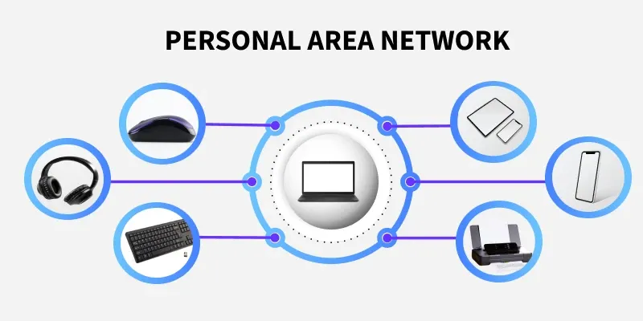

2. LAN – Local Area Network
Work / Function:
Connects computers within a small area like a room, office, school, or building.
Advantages:
- High speed
- Easy data sharing
- Good security
- Low data transmission cost
Disadvantages:
- Limited coverage area
- Setup cost
- Requires maintenance
- Needs technical support
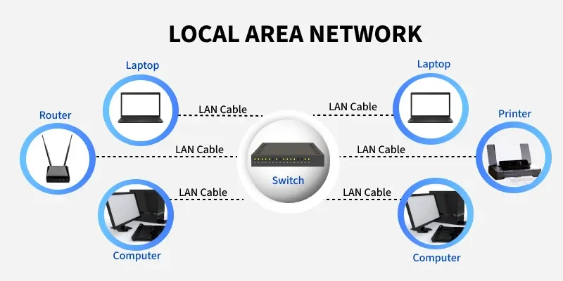

2. WLAN – Wireless Local Area Network
Work / Function:
LAN without cables, uses Wi-Fi technology.
Advantages:
- No wiring needed
- Mobility (move freely)
- Easy installation
- Convenient for mobile devices
Disadvantages:
- Security risk (hacking)
- Signal interference
- Speed fluctuation
- Limited range

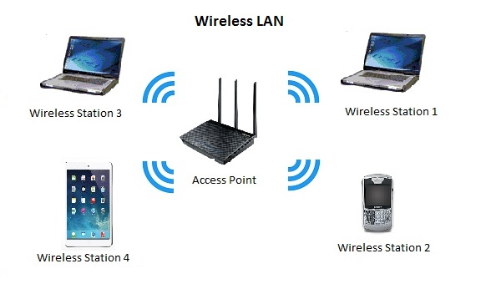

3. MAN – Metropolitan Area Network
Work / Function:
Covers a city or metropolitan area.
Advantages:
- Large coverage
- High-speed connectivity
- Efficient city-level communication
- Better than WAN in speed
Disadvantages:
- High cost
- Complex maintenance
- Security threats
- Technical dependency
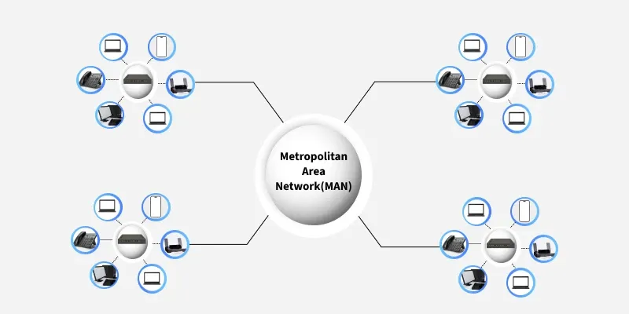

4.WAN – Wide Area Network
Work / Function:
Covers countries or the whole world.
Example: The Internet.
Advantages:
- Global connectivity 🌍
- Long-distance communication
- Cloud services possible
- Worldwide data sharing
Disadvantages:
- High security risks
- Slower than LAN
- Expensive infrastructure
- Network failure impact is large
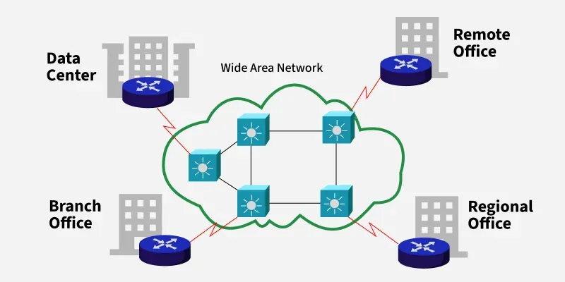

Network Topology
1. Bus Topology
Use:
- Small offices
- Old LAN systems
- Temporary networks
Why used: Low cost, easy to install
Problem: If main cable fails → whole network down

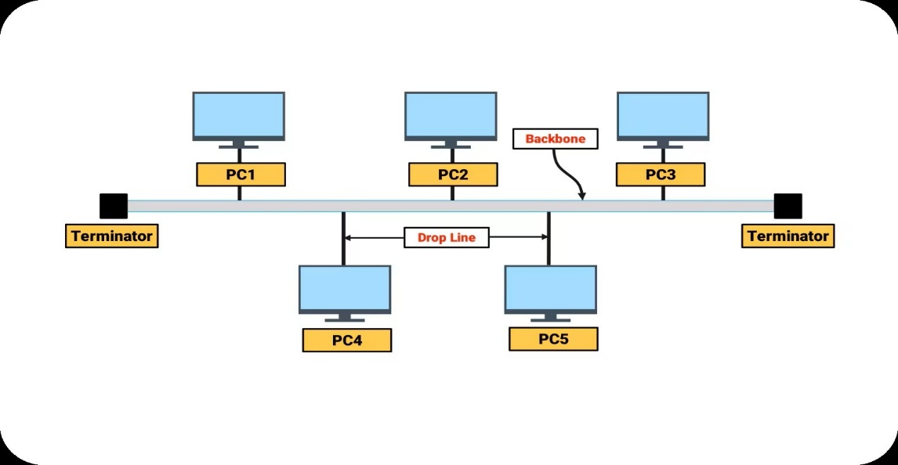

2. Star Topology
Use:
- Homes
- Schools
- Offices
- Computer labs
- Banks
Why used: Easy to manage, one PC failure doesn’t affect others
Device used: Switch / Hub

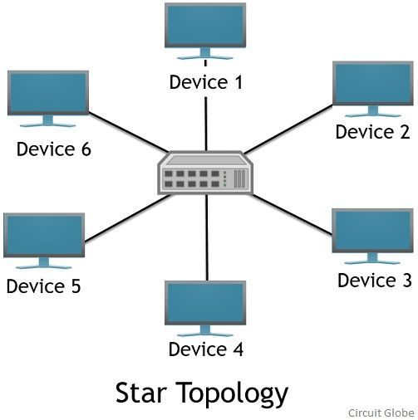

3. Ring Topology
Use:
- Old telecom networks
- Some industrial systems
Why used: Data flows in one direction → no collision
Problem: One break = whole network fails

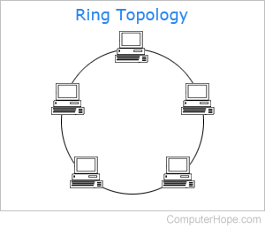
4. Mesh Topology
Use:
- Military networks
- Banking systems
- Data centres
- Internet backbone
Why used: Very secure, high reliability
Problem: Very expensive, complex

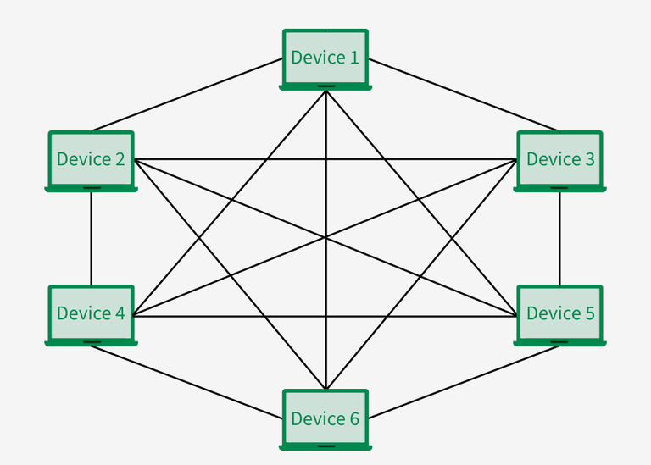
5. Tree Topology
Use:
- Universities
- Corporate buildings
- Large organizations
Why used: Scalable, structured hierarchy
Combination of: Star + Bus

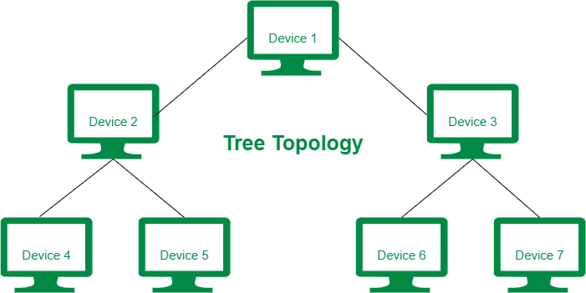

6. Hybrid Topology
Use:
- Large companies
- Hospitals
- Smart campuses
- Airports
Why used: Flexible design, high performance
Combination of: Two or more topologies

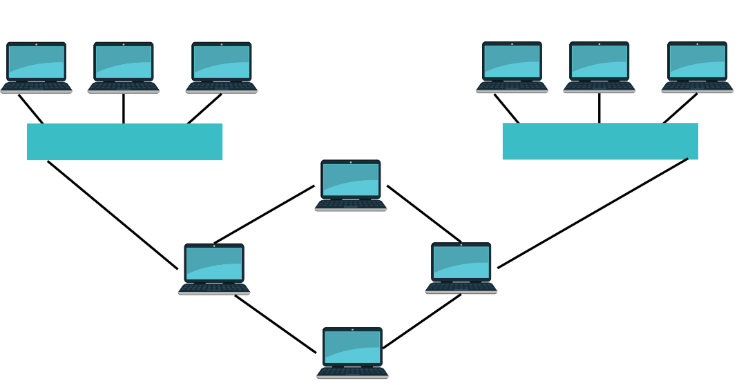

Database Management Systems (DBMS)
- Database: Structured data organized for quick access and management.
- DBMS Examples: MySQL, Oracle, SQL Server
- SQL: Structured Query Language for managing databases.
- Importance: Data integrity, security, and scalability.
Difference between SQL and MySQL:
SQL is the language used to talk to databases.
MySQL is a software system that understands SQL and manages data.
Information Security and Cybersecurity
- Protects data and systems from unauthorized access or damage.
- Threats: Viruses, Malware, Phishing, Ransomware
- Security Measures: Firewalls, Encryption, Authentication
- Policies: Data backup, user training, network monitoring.

Cloud Computing

- Provides computing services (servers, storage, databases) over the Internet.
- Models: IaaS, PaaS, SaaS
- Benefits: Scalability, cost-efficiency, accessibility
- Providers: AWS, Microsoft Azure, Google Cloud

Emerging IT Technologies

- Artificial Intelligence – Machine learning, automation, NLP
- Internet of Things (IoT) – Smart devices connected via the Internet
- Blockchain – Secure, decentralized data ledger
- Big Data – Analysis of massive datasets for insights

Applications of IT in Business

- E-commerce and Digital Marketing
- Enterprise Resource Planning (ERP)
- Customer Relationship Management (CRM)
- Business Intelligence and Analytics
- Remote work, collaboration, and automation tools

IT in Education and Society

- E-learning platforms and virtual classrooms
- Digital libraries and research tools
- Social media and digital communication
- IT’s impact on social awareness and global connectivity

The Role of Information Technology in Modern Business

Information Technology (IT) plays a vital role in transforming how businesses operate, communicate, and compete in today’s digital world. It supports every aspect of modern business — from daily operations to strategic decision-making.

Key roles of IT in modern business:

- Increased efficiency: IT automates repetitive tasks, reduces manual labor, and minimizes errors, which leads to increased productivity and consistency across departments.
- Improved communication: It provides tools like email, instant messaging, and video conferencing that facilitate real-time communication and collaboration among employees, clients, and partners.
- Data-driven decision-making: Advanced analytics tools allow businesses to collect, analyze, and interpret vast amounts of data to gain insights for strategic planning and performance monitoring.
- Innovation and competitiveness: IT provides platforms and tools for research and development, allowing companies to create innovative products and services and gain a competitive edge.
- Supply chain optimization: Sophisticated software helps businesses track inventory, manage logistics, and improve demand forecasting, which reduces costs and ensures timely deliveries.
- Enhanced customer experience: IT systems like CRM software allow businesses to track customer information and preferences, while tools like chatbots provide instant customer service.
- Cybersecurity: IT professionals use advanced security measures like firewalls, encryption, and intrusion detection systems to protect sensitive data from cyber threats and safeguard the company's reputation.
- Scalability and flexibility: Cloud computing, for example, provides businesses with scalable storage and access to data from anywhere, allowing them to grow and adapt their operations as needed.

Enterprise Resource Planning

Enterprise Resource Planning (ERP) is a software system that integrates and manages core business processes like finance, HR, supply chain, and manufacturing into a single, unified platform. By centralizing data, ERP streamlines operations, improves efficiency, and provides a real-time, single source of truth for an organization's activities. It allows different departments such as finance, HR, sales, supply chain, inventory, and manufacturing — to share information and work efficiently together.

Key Features of ERP Systems

1. Centralized Database
- All departments use one common database
- Avoids duplicate data
- Ensures data accuracy & consistency

2. Integration of Business Processes
- Connects all departments like:
  - Finance
  - HR
  - Sales
  - Purchase
  - Inventory
  - Production
- Everything works as one system

3. Real-Time Information
- Data updates instantly
- Helps in:
  - Fast decision-making
  - Live reporting
  - Accurate tracking

4. Automation
- Automatic handling of tasks like:
  - Billing
  - Payroll
  - Inventory updates
  - Purchase orders
- Reduces manual work & errors

5. Modular Structure
- ERP is divided into modules:
  - HR Module
  - Finance Module
  - Sales Module
  - Inventory Module
- Companies can use only what they need

6. Scalability
- System can grow with business
- Easy to add:
  - New users
  - New branches
  - New modules

7. Security & Access Control
- Role-based access
- Example:
  - HR can access HR data
  - Accounts can access finance data
- Ensures data protection

8. Reporting & Analytics
- Auto-generated reports
- Dashboards for management
- Helps in:
  - Performance analysis
  - Business planning
  - Forecasting

9. Standardization of Processes
- Same process flow across departments
- Improves efficiency & discipline

10. Customer Relationship Management (CRM) Integration
- Tracks:
  - Customers
  - Orders
  - Complaints
  - Service history
- Improves customer satisfaction

Examples of Popular ERP Systems:
- SAP
- Oracle NetSuite
- Microsoft Dynamics 365
- Odoo
Core Modules in ERP

- Finance and Accounting
- Human Resource Management (HRM)
- Inventory Management
- Sales and Marketing
- Customer Relationship Management (CRM)
- Supply Chain Management (SCM)
- Production/Manufacturing Management

Benefits of ERP

- Improved efficiency and productivity
- Enhanced data accuracy and reporting
- Better decision-making with real-time data
- Lower operational costs
- Greater collaboration across departments
- Stronger customer satisfaction

How Enterprise Resource Planning Platforms Work

Enterprise Resource Planning (ERP) platforms work by integrating all of a company's core business functions, like finance, HR, and supply chain, into a single system that uses a central database. This structure allows different departments to share information in real-time, automate processes, and create seamless workflows that streamline operations and improve decision-making.

Centralized Database

- The core of an ERP system is a central database.
- All departments (Finance, HR, Sales, Inventory, etc.) store and access data from this one database.
- This avoids data duplication and ensures real-time consistency across the organization.
Example:
When the sales team records a new order, the inventory and accounting modules are automatically updated.

Integration of Business Processes

- ERP connects different departments so that their workflows are interlinked:
- Sales → Triggers order processing
- Inventory → Checks stock availability
- Production → Plans manufacturing
- Finance → Records revenue and updates accounts
- This end-to-end integration improves efficiency and accuracy.

Automation of Tasks

- ERP automates routine and repetitive tasks, such as:
- Generating invoices
- Updating stock levels
- Processing payroll
- Tracking shipments
- Automation saves time, reduces manual errors, and increases productivity.

Real-Time Data and Reporting

- ERP provides real-time dashboards and analytics for managers.
- Decision-makers can monitor sales, expenses, inventory, and performance instantly.
- Helps identify issues early and supports data-driven decisions.

Modular Structure

- ERP systems are built using modules, each focusing on a specific area of business:
- Finance Module: Manages accounting and budgeting.
- HR Module: Handles employee data and payroll.
- Inventory Module: Tracks stock and supplies.
- Sales Module: Manages customer orders and billing.
- Companies can implement modules as needed and expand later.

Cloud and On-Premise Deployment

- On-Premise ERP: Installed locally on company servers.
- Cloud ERP: Hosted online and accessed via the internet.
- Many modern systems offer hybrid solutions, combining both.
Security and Access Control
- ERP systems use role-based access control, meaning users only access data relevant to their job.
- Includes data encryption, backups, and user authentication to protect sensitive information.
Continuous Updates and Scalability

- ERP platforms are updated regularly to include new features and security enhancements.
- They can scale as the business grows — adding more users, departments, or modules easily.
Types of ERP
1. On-Premise ERP
Installed on company’s own servers
Features:
- Full control over data
- High customization
- High initial cost
Examples:
- SAP ERP
- Oracle ERP
Best for: Large enterprises, banks, government sectors

2. Cloud-Based ERP
Runs on internet (cloud servers)
Features:
- Low setup cost
- Access from anywhere
- Automatic updates
- Subscription-based
Examples:
- Oracle NetSuite
- SAP S/4HANA Cloud
Best for: Startups, SMEs, growing businesses

3. Hybrid ERP
Mix of On-premise + Cloud
Features:
- Flexible system
- Secure + scalable
- Balanced cost
Best for: Mid-large organizations

4. Industry-Specific ERP
Designed for specific industries
Industry | ERP Type
Hospital | Healthcare ERP
School/College | Education ERP
Factory | Manufacturing ERP
Retail | Retail ERP
Hotel | Hospitality ERP

5. Open-Source ERP
Free source code, customizable
Features:
- Low cost
- High flexibility
- Needs technical team
Examples:
- Odoo
- ERP Next

6. Functional ERP Types (by purpose)
- Finance ERP
- HR ERP
- Inventory ERP
- CRM ERP
- Supply Chain ERP
- Manufacturing ERP
Benefits of ERP

- ERP systems provide many advantages by integrating different business functions into a single platform.
- Increased productivity and efficiency: Automating routine tasks reduces manual data entry and errors, speeding up operations.
- Cost savings: Streamlining processes, optimizing inventory, and improving supply chain management can lead to lower operational and inventory costs.
- Improved financial management: ERP systems simplify financial reporting, accelerate the financial close process, and provide accurate cash flow projections.
- Real-time data and analytics: A single source of truth provides real-time visibility into operational and financial performance, supporting faster and more informed decision-making.
- Better inventory management: Automation of inventory management reduces handling costs and helps optimize cash flow by ensuring sufficient stock levels.

- Enhanced collaboration: Centralizing data allows different departments to share information easily, improving teamwork and productivity.
- Improved customer service: Better access to customer information allows for quicker response times and more effective complaint resolution.
- Increased agility: Businesses can react more quickly to opportunities and market changes due to real-time data and more efficient operations.
- Scalability: ERP systems can grow with the business, allowing companies to add new functionalities as they expand without disrupting existing operations.
- Regulatory compliance: Automation of controls and the provision of audit trails help ensure businesses meet regulatory requirements.
- Enhanced data security: Role-based access controls and data encryption improve the protection of sensitive business information.

ERP vs CRM

ERP vs CRM (Difference Table)
Topic | ERP | CRM
Focus | Internal business process | Customers
Main aim | Efficiency & control | Sales & relationships
Users | Admin, HR, Finance, Operations | Sales, Marketing, Support
Data type | Company data | Customer data
Example work | Payroll, inventory, accounts | Leads, sales, support tickets

ERP (Enterprise Resource Planning)
Main Focus: Business operations & internal management
What it does:
ERP software manages a company’s internal processes, such as:
- Accounting & Finance
- Human Resources (HR)
- Inventory Management
- Supply Chain
- Manufacturing
- Payroll
- Procurement
Goal:
Run the organization efficiently from inside
Example functions:
- Stock control
- Salary processing
- Purchase orders
- Production planning

CRM (Customer Relationship Management)
Main Focus: Customers & relationships
What it does:
CRM software manages customer-related activities, such as:
- Customer data
- Sales tracking
- Marketing campaigns
- Customer support
- Lead management
- Follow-ups
Goal:
Improve customer satisfaction and sales
Example functions:
- Customer call history
- Email marketing
- Sales pipeline
- Complaint handling

The Relationship between Business Strategy, IT Strategy and Alignment Capability

Business strategy, IT strategy, and alignment capability are interdependent: Business strategy sets the overall goals, IT strategy defines how technology will support those goals, and alignment capability is the organization's ability to effectively coordinate the two.
Business Strategy: A business strategy defines the goals, direction, and long-term plans of an organization.

Examples:
- Expanding into new markets
- Increasing product quality
- Reducing operational costs
- Enhancing customer experience

IT Strategy:
IT strategy defines how technology will support the business strategy.
It includes decisions on:
- Infrastructure (cloud, servers, networks)
- Applications (ERP, CRM, BI tools)
- Cybersecurity
- IT investments and priorities
Purpose:
Ensure IT systems enable, support, and strengthen the organization’s objectives.

Alignment Capability:
Alignment capability is an organization’s ability to synchronize business and IT strategies so they work together effectively.
It includes:
- Good communication between IT and business teams
- Strong leadership and collaboration
- Shared goals and understanding
- Flexible processes
- Governance and change management
Even if a company has a great business plan and strong technology, it fails if the two are not aligned.

How They Work Together:

A. Business Strategy → Drives IT Strategy
Business goals determine what IT systems are needed.
Example:
If the business strategy focuses on customer experience → IT invests in CRM, chatbots, website optimization.
B. IT Strategy → Enables Business Strategy
IT provides the tools and infrastructure to execute the business plan.
Example:
If the business wants global expansion → IT sets up cloud platforms, e-commerce systems, and ERP modules.
C. Alignment Capability → Ensures Continuous Fit
Business environment and technology both change.
Alignment capability ensures the two strategies stay coordinated over time through:
- Regular reviews
- Cross-department communication
- Agile adjustments
- Shared decision-making

The Alignment Cycle:

- Business Strategy is created
- IT Strategy is designed to support it
- Alignment Capability ensures both strategies stay connected
- IT improves business performance, which shapes future business strategy
- The cycle repeats

Difference between Structured, Semi-structured and Unstructured data

In today’s data-driven economy, businesses are inundated with information from thousands of sources, including CRMs, web apps, IoT devices, social media, internal systems, and third-party APIs. To make sense of this information and drive smarter decisions, organizations must understand how data is categorized and handled.
Broadly, data falls into three categories:
- Structured data
- Unstructured data
- Semi-structured data

Structured Data:
Data that is highly organized and stored in a fixed, tabular format (rows & columns) so that it can be easily entered, stored, queried, and analyzed.
Characteristics:
- Follows a predefined schema (fixed columns like Name, Age, Salary).
- Easy to search, filter, and analyze using SQL.
- Stored in relational databases (RDBMS).
Examples:
- Excel sheets
- SQL database tables (e.g., Students table, Sales table)
- Bank transaction records
- Employee records (Emp ID, Name, Dept, Salary)

Semi-structured Data
Data that does not follow a strict tabular format, but still has some organizational structure using tags or markers.
Characteristics:
- No fixed row-column format.
- Has tags, key–value pairs or hierarchical structure.
- Easier to organize than unstructured data, but harder than structured data.
- Often used in web and big data applications.
Examples:
- JSON files
- XML files
- HTML pages
- Emails (subject, from, to, body – some structure + free text)
- NoSQL databases (like MongoDB documents)

Unstructured Data
Data that has no predefined structure or schema, and does not fit into rows and columns.
Characteristics
- Mostly free-form content.
- Difficult to store in traditional databases.
- Requires techniques like text mining, NLP, image processing for analysis.
- Makes up a large portion of real-world data.
Examples
- Text documents (Word, PDFs)
- Images, photos
- Audio files, videos
- Social media posts, comments, chats
- Scanned documents
Common Data Sources (internal data, third-party analytics, external data and open data)

Organizations use different data sources for analysis and decision-making. These include internal data, third-party analytics, external data, and open data.
Internal Data: Internal data is the data generated and stored within an organization during its day-to-day operations.

Examples:
- Sales records, invoices, billing data
- Customer details from CRM
- Employee records, attendance, payroll
- Inventory and stock levels
- Production and logistics data
Key Points:
- Usually stored in internal databases, ERP, CRM, HR systems.
- Considered reliable and confidential.
- Main source for management reports, KPIs, and performance analysis.
Third-Party Analytics: Third-party analytics refers to data and insights provided by external analytics service providers or platforms that collect and analyze data on behalf of many clients.
Examples:
- Website traffic data from tools like Google Analytics
- Social media analytics from platforms or marketing tools
- Market research reports bought from research firms
- Advertising performance data from ad platforms
Key Points:
- Helps organizations understand user behaviors, marketing performance, trends.
- Often provided via dashboards, reports, or APIs.
- Useful when a company doesn’t have its own advanced analytics tools.

External Data: External data is data that comes from outside the organization, collected from other companies, institutions, or the general environment.
Examples:
- Market trends and competitor information
- Customer demographics from external agencies
- Industry reports and statistics
- Supplier and vendor data
Key Points:
- Used to understand the business environment and competition.
- Often obtained through subscriptions, data vendors, industry bodies.
- Complements internal data for better forecasting and strategy.

Open Data: Open data is data that is freely available to everyone to use, reuse, and share, usually published by governments, public organizations, or international bodies.
Examples:
- Government census data
- Health, education, and crime statistics
- Weather and climate data
- Transport and traffic data
- Open data portals (national or city-level)

Key Points:
- Generally free or low-cost.
- Promotes research, innovation, transparency, and public services.
- Can be combined with internal data for deeper analysis and insights.

Data Collection:
Data collection is the process of gathering information from various sources to answer questions, test hypotheses, or make decisions. It is used in research, business, education, government, and data analytics.
Types of Data (Based on Nature)
a) Qualitative Data (Non-numerical)
- Descriptive, textual information
- Answers “why” and “how”
Examples: opinions, feedback, comments, interview responses
b) Quantitative Data (Numerical)
- Data in numbers
- Answers “how much”, “how many”
Examples: marks, sales figures, age, income, rating (1–5)
Data collection methods are often chosen based on whether you need qualitative or quantitative data.

Types of Data Collection (Based on Source)

Primary Data Collection
Data collected first-hand by the researcher for a specific purpose.
Methods: surveys, interviews, experiments, observations, focus groups.
Advantage: Original and specific
Disadvantage: Takes more time and cost.

b) Secondary Data Collection
Data collected from existing sources that were gathered by others.
Sources: books, websites, reports, research papers, government data.
Advantage: Quick and cheap
Disadvantage: May be less relevant or outdated.

Introduction to data lifecycle management (DLM)

- Data Life Cycle Management (DLM) is all about how data is handled from the moment it is created until it is no longer needed and is deleted or archived.
- Main Stages of the Data Life Cycle:

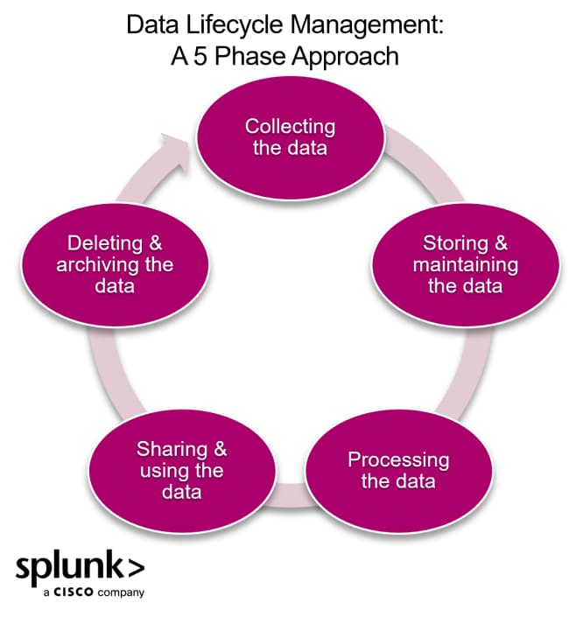

What Do Business Analysts Do?
Business analysts assess an organization's current processes, systems, and products to identify areas for improvement, increase efficiency, and boost revenue. They act as a bridge between business needs and solutions by gathering requirements, analyzing data, and communicating insights to stakeholders to help guide strategic decisions and implement changes.

Key responsibilities:

- Analyzing business needs: They research and identify the organization's functional and technical needs and requirements to solve problems or capitalize on opportunities.
- Data analysis: They analyze large datasets using tools like SQL and Excel to find trends, create reports, and build financial models to support decision-making.
- Process improvement: They evaluate existing processes, identify inefficiencies, and propose solutions, which can include recommending new technology, policies, or system changes.
- Requirements gathering: They collect detailed requirements from stakeholders and use them to define the scope of projects.
- Communication and documentation: They create reports and presentations to communicate their findings to senior management and other stakeholders.
- Solution implementation: They may help oversee the implementation of new systems or processes and ensure they meet the defined requirements and provide value to the business.
Skills of a Business Analyst
- Analytical thinking
- Communication skills (talking to both business & technical people)
- Problem-solving
- Documentation and modelling
- Basic knowledge of databases, Excel, BI tools
- Understanding of business domains (finance, sales, operations, etc.)
The Tools Used by Business Analysts
To carry out all these responsibilities, business analysts rely on a variety of tools to manage their tasks efficiently. Some of the most common tools include:
- Requirements Management Tools: Tools like JIRA, Confluence, or Trello are used to document and track requirements, user stories, and tasks.
- Data Analysis Tools: Business analysts often use software like Microsoft Excel, Google Analytics, and Tableau to analyze data and create visual reports.
- Process Mapping Tools: Tools such as Microsoft Visio or Lucidchart help business analysts create diagrams to map processes and workflows.
- Collaboration Tools: Platforms like Slack, Zoom, and Microsoft Teams facilitate communication and collaboration with stakeholders and team members.

Collaboration and Relationship-Building in Business Analysis

Collaboration and relationship-building in business analysis refer to how a Business Analyst works with stakeholders, builds trust, and maintains effective communication to successfully deliver projects and solutions.
Key benefits include:
- Comprehensive Requirements: Working closely with diverse stakeholders helps uncover all necessary information, leading to complete and accurate requirements .
- Increased Buy-in: Involving stakeholders in the analysis process makes them feel heard, which increases their support for the final solution .
- Risk Mitigation: Open communication channels help identify potential issues early, allowing the team to address them proactively .
- Faster Decision Making: Trusting relationships allow for more efficient conflict resolution.

Business Analysis Methodologies
Business analysis uses methodologies like Agile and Water fall .
Agile is a flexible, iterative approach focused on continuous feedback and collaboration, while Waterfall is a sequential, linear model that emphasizes thorough upfront planning and distinct, consecutive phases to manage projects.
Waterfall methodology:
Approach: A linear, sequential process where each phase must be completed before the next begins.
Phases: Typically includes requirements gathering, design, implementation, verification, and maintenance.
Best for: Projects with stable requirements that are well-defined from the start.

Role of BA in Waterfall
Gather complete requirements at the beginning.
Prepare detailed documentation (BRD, SRS, use cases).
Get sign-off from stakeholders before development starts.
Limited scope for change later.
Advantages
- Clear structure and planning.
- Good for stable, well-understood requirements.
- Strong documentation.
Disadvantages
- Not flexible to changes.
- Feedback comes late, after development.
- Risk of building something that doesn’t match user needs if requirements change.

Agile methodology:
Approach: Iterative and incremental, focusing on flexibility, collaboration, and responding to change.
Key principles: Embraces feedback, breaks work into smaller pieces, and uses short, time-boxed cycles (sprints) to deliver value continuously.
Popular frameworks: Includes Scrum, Kanban, and Lean.
Best for: Projects where requirements may evolve or change, and where continuous feedback is valuable.
Role of BA in Agile:
- Work closely with Product Owner and development team.
- Help write and refine user stories with acceptance criteria.
- Participate in:
  - Sprint planning
  - Daily stand-up meetings
  - Sprint review
- Continuously prioritize and clarify requirements.
- Focus more on communication and collaboration than heavy documentation.
Advantages
- Very flexible with changing requirements.
- Regular feedback from users.
- Delivers working software faster and more frequently.
Disadvantages
- Needs high team involvement and collaboration.
- Documentation may be lighter.
- Difficult if stakeholders are not available regularly.

Waterfall Model vs Agile Model

Basis | Waterfall Model | Agile Model
Approach | Linear & sequential | Iterative & incremental
Process Flow | One phase completes before the next starts | Multiple cycles (sprints/iterations)
Flexibility | Rigid (changes are difficult) | Highly flexible
Customer Involvement | Low (mainly at start & end) | High (continuous feedback)
Project Planning | Fully planned at beginning | Adaptive planning
Testing | After development phase | Continuous testing
Documentation | Heavy documentation | Minimal but sufficient documentation
Delivery | Final product delivered at the end | Frequent small releases
Risk Handling | High risk (late error detection) | Low risk (early feedback & fixes)
Best For | Fixed requirements, stable projects | Changing requirements, dynamic projects
When to Use Waterfall
- Requirements are clear and stable: The project has a well-defined scope from the start.
- The project is straightforward and uncomplicated: A linear approach works well for simple projects with no unknowns.
- Strict documentation and regulatory compliance are required: Waterfall's structured phases support thorough documentation needs.
- Customer involvement is limited: It's best when client input is primarily at the beginning and end of the project.
- A fixed schedule and budget are the main drivers: Its structure allows for a clear, upfront plan for costs and timelines.

When to Use Agile
- Requirements are likely to change: Agile's flexible, iterative approach is ideal for projects with evolving needs.
- Fast delivery is a priority: It allows for incremental releases of functional parts of the product.
- Customer feedback is crucial: The methodology builds in continuous collaboration and feedback loops.
- The project is complex or uncertain: It accommodates innovation and emerging technologies by allowing for rapid iterations.
- Cross-functional teams work collaboratively: Agile thrives when developers, designers, and testers work together in cycles.
Stakeholder management
Stakeholder management is the process of identifying, analyzing, and engaging with individuals, groups, or organizations that can affect or are affected by a project or business. Its goal is to manage stakeholders' interests and expectations to ensure the initiative's success by building positive relationships and trust. This involves communication, understanding their needs, and managing expectations to achieve the project's objectives.

The Benefits of Stakeholder Management
Effective stakeholder management leads to improve project success by ensuring clearer communication, managing expectations, and fostering stronger relationships.

Project and operational benefits
- Increases project success: Involving stakeholders early and often helps to ensure project requirements are fully understood and accepted, increasing the likelihood of a successful outcome.
- Manages and mitigates risk: Identifying stakeholders and their concerns early allows for the development of risk management strategies and helps prevent delays and disruptions.
- Improves decision-making: A clear understanding of stakeholders, their needs, and their resources enables more effective stewardship of time and financial resources.
- Boosts engagement and motivation: Clarifying roles and expectations encourages more active and effective participation from stakeholders.
- Fosters collaboration: Communication and collaboration are improved when an organization understands stakeholder preferences and roles, leading to greater efficiency.
Relationship and trust benefits
- Builds trust and confidence: Transparent and clear communication demonstrates a commitment to stakeholders' needs and builds trust.
- Strengthens relationships: Proactive engagement helps to build and maintain strong relationships with all parties involved.
- Manages expectations: A structured approach ensures that stakeholder expectations are managed realistically, which increases satisfaction.

Strategic and competitive benefits
- Provides a competitive advantage: Understanding stakeholder interests can uncover opportunities for innovation and provide a competitive edge.
- Enhances reputation: Proactively managing stakeholder relationships can improve a company's reputation and develop a social license to operate.
- Offers "business intelligence": Insights from stakeholders about their needs can lead to new product or service ideas and identify areas for cost reduction or value maximization.

Key aspects of stakeholder management
- Identification: Recognizing all individuals, groups, and organizations that have a vested interest in a project, such as employees, customers, investors, regulators, and local communities.
- Analysis: Understanding each stakeholder's needs, interests, influence, and potential impact on the project.
- Prioritization: Ranking stakeholders based on their importance and influence to focus on those with the most significant impact.
- Engagement: Developing and implementing strategies to interact and communicate effectively with stakeholders, which includes managing their expectations and building trust.
- Communication: Establishing clear and organized channels for communication to keep stakeholders informed and address their concerns proactively.
What Is Scenario Analysis?
Scenario analysis in business is the process of creating and evaluating different possible future situations (scenarios) — such as best case, worst case, and most likely case — to understand their impact on the organization and make better decisions.
Purpose of Scenario Analysis:
- To anticipate risks and opportunities
- To see how changes in key factors (price, demand, cost, interest rates, etc.) will affect profit, cash flow, growth, etc.
- To support strategic planning and decision-making
- To avoid being shocked by sudden changes in the market or environment
Examples:
1. Sales Revenue Scenario
Business Question:
“What happens to our profit if sales go up or down?”
Scenarios:
- Best-case: Sales increase by 30%
- Most-likely: Sales increase by 10%
- Worst-case: Sales decrease by 15%
Analysis:
The company calculates revenue and profit under each scenario and decides:
- How much stock to buy
- Whether to hire more staff
- Whether to offer discounts
Helps in sales planning and budgeting.

2. New Product Launch Scenario
Business Question:
“Should we launch a new product next year?”
Scenarios:
- Best-case: High customer demand, low competition → high profit
- Most-likely: Moderate demand → average profit
- Worst-case: Low demand, high marketing cost → loss
Analysis:
The business estimates:
- Expected sales
- Marketing cost
- Production cost
Then decides whether to proceed, delay, or cancel the product launch.
Helps in strategic decision-making.

Key aspects of scenario analysis:
- Evaluates multiple futures: Instead of relying on a single forecast, scenario analysis explores a range of potential outcomes by changing key assumptions about variables like interest rates, market demand, or operating costs.
- Identifies risks and opportunities: It helps businesses anticipate both negative events (like a sudden increase in raw material costs) and positive ones (like a surge in market demand).
- Supports decision-making: By providing a clearer picture of potential outcomes, it helps leaders make more robust decisions about investments, operations, and strategy.
- Develops contingency plans: The analysis allows companies to create actionable plans for different scenarios, so they are better prepared to react to unexpected events.
- Focuses on comprehensive change: Unlike sensitivity analysis, which often changes one variable at a time, scenario analysis changes multiple variables simultaneously to create more comprehensive future scenarios.
How it is used:
- Financial planning: It can be used to forecast the potential impact on cash flow and business value.
- Risk management: It helps identify and mitigate potential risks associated with various external factors.
- Strategic initiatives: It provides a framework for developing long-term strategies and evaluating potential courses of action.
- Investment decisions: It can be used to evaluate the potential returns and risks of major investments.
What is data governance?
Data governance is the set of policies, rules, roles, and processes that an organization uses to ensure its data is correct, secure, consistent, and used responsibly.

Main Goals of Data Governance:
- Ensure data is accurate and consistent
- Protect data from unauthorized access or misuse
- Define who owns the data and who can do what (view, edit, delete)
- Comply with laws and regulations (like privacy rules)
- Make data trustworthy for reporting and decision-making

Key Elements
- Defines rules and responsibilities: It establishes who can do what with data, providing a common playbook for handling data responsibly.
- Ensures data quality and integrity: It helps prevent errors, inconsistencies, and duplication by setting standards for data throughout its lifecycle, from creation to disposal.
- Improves security and privacy: It includes policies to protect sensitive data, control access, and maintain compliance with regulations like GDPR and HIPAA.
- Enhances usability and accessibility: By ensuring data is trustworthy, governance makes it easier for people to find and use the data they need for business intelligence and other initiatives.
- Supports better decision-making: With a consistent, high-quality data foundation, organizations can make more confident and informed decisions.

What are the benefits of data governance?
Improved Data Quality
- Ensures data is accurate, complete, and consistent.
- Reduces errors, duplicates, and outdated information.
- Leads to more reliable reports and analysis.
Better Decision-Making
- When data is clean and well-managed, managers can trust the data.
- Decisions based on such data are more accurate and effective.
- Supports data-driven decision-making.
Enhanced Data Security & Privacy
- Defines who can access, edit, or delete data.
- Protects sensitive data (like customer or employee information).
- Helps prevent data leaks, misuse, and unauthorized access.

Compliance with Laws and Regulations
- Helps organizations follow data protection laws (like GDPR, privacy rules, audit requirements).
- Avoids legal penalties, fines, and reputational damage.
Clear Roles and Responsibilities
- Defines data owners, data stewards, and users.
- Everyone knows who is responsible for which data.
- Reduces confusion and improves accountability.

Consistent Data Across Systems

- Ensures that data is standardized across different departments and systems.
- For example, customer data is the same in CRM, ERP, and reports.
- Avoids conflicting numbers and confusion.

Reduced Costs and Higher Efficiency
- Less time spent on fixing data errors.
- Fewer duplicate systems or unnecessary data storage.
- Improves operational efficiency and reduces storage and processing costs.
Better Support for Analytics and BI
- Good data governance ensures high-quality input data for:
    - Business Intelligence (BI)
    - Dashboards
    - Data analytics and AI
- Results are more meaningful and trustworthy.

What is the Ethical Use of Data?
The ethical use of data involves following principles like consent and transparency, fairness and non-discrimination, data minimization, and accountability when collecting, using, and managing data. This means getting clear permission from individuals, being open about how their data is used, ensuring data doesn't perpetuate bias, collecting only what is necessary, and taking responsibility for any data-related issues that arise.
Key principles of ethical data use:
Consent and Transparency:
Obtain informed consent before collecting data and be transparent about what data you are collecting, why, and how it will be used. Individuals should understand their rights and the implications of sharing their information.
Fairness and Non-Discrimination:
Avoid using data in ways that perpetuate bias or discrimination. This requires actively identifying and mitigating biases in data collection and analysis to ensure fair outcomes.
Data Minimization:
Collect only the data that is necessary for a specific purpose. Avoid collecting excessive data, which not only respects individual privacy but also reduces the risk associated with handling large volumes of sensitive information.

Accountability:
Take responsibility for how data is handled throughout its lifecycle, including its collection, use, and disposal. This means establishing governance and having clear lines of responsibility, especially when something goes wrong, such as a data breach.
Privacy and Security:
Protect personal data from unauthorized access and ensure it is stored and transmitted securely.
Integrity and Quality:
Ensure the accuracy and reliability of the data used to make decisions, as data quality is crucial for trustworthy outcomes.
CCPA vs GDPR compliance: Similarities and Differences
Key Similarities:
Goal: Both regulations share the primary objective of protecting individual data privacy rights and enhancing transparency in data handling practices.
Global Reach: Both laws can apply to organizations worldwide, provided they process the personal data of EU residents (GDPR) or California residents (CCPA), regardless of the business's physical location.
Consumer Rights: Both grant individuals similar core rights concerning their data, including the right to know what data is collected, the right to access that data, and the right to request its deletion (right to erasure).
Security Measures: Both require organizations to implement reasonable security measures to protect personal data and mandate breach notifications to affected individuals.
Penalties: Both laws impose significant fines for non-compliance, aiming to deter violations and ensure accountability.

Key Differences :

Aspect | CCPA (California Consumer Privacy Act) | GDPR (General Data Protection Regulation)
Region | California, USA | European Union (EU)
Full Form | California Consumer Privacy Act | General Data Protection Regulation
Year Enforced | 2020 | 2018
Scope | Applies to businesses dealing with California residents | Applies to organizations handling EU citizens' data
Type of Law | Privacy + Consumer rights law | Comprehensive data protection law
Who It Applies To | Large businesses & data-selling companies | All organizations processing EU data
Consent Model | Opt-out model | Opt-in model
Data Collection | Allowed unless user opts out | Allowed only with user consent
User Rights | Know, delete, opt-out of sale, access data | Access, delete, correct, restrict, portability, object
Data Sale | Users can opt-out of data selling | Data selling requires consent
Age Protection | Under 16 need parental consent | Under 16 (or 13–16 per country laws) protected
Penalties | Fines + lawsuits | Very high fines
Max Fine | $7,500 per violation | €20 million or 4% of global turnover
Focus | Consumer privacy rights | Data protection + privacy rights
Data Breach Reporting | Not strict | Mandatory within 72 hours
Global Reach | Only California-based impact | Global impact if EU data is involved

